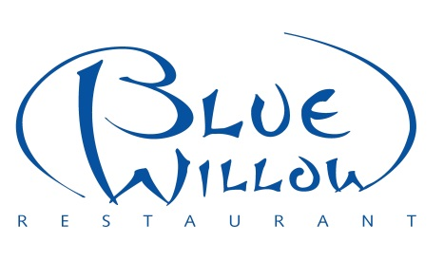
DONATION FORM

SUZANNE MAH MEMORIAL GOLF TOURNAMENT
Sunday, June 11, 2017
Deadline for Donations: Wednesday, June 1st, 2017

Contact Name: ____________________________ Phone Number: ________________

Business Name: ________________________Address: _________________________

Please indicate name to appear on the donation list: _____________________________

Donation Item(s):___________________________________________Quantity: _____

Please check the following: ___ dropping this off at Blue Willow Restaurant
(11107-103 Avenue)
___ please pick this item up at _____________________

** Below are some general rules of thumb for an Official Tax Receipt from the Cross Cancer Institute for a fundraising event. **

- All donated items from companies that are greater than $1,000 require an appraisal.
- Regardless of the marked value, all artwork donations require an external appraisal.
- Gift certificates from companies do not qualify for an income tax receipt as the company will still be benefiting from the exchange.
- All donated items that are less than $1,000 would qualify for an income tax receipt as long as we have back-up of the cost of the item (e.g. Receipt)

___ No tax receipt required just a letter of thanks for marketing expense.

___ Yes, I would like a Tax Receipt.
(Please fill in the information below and attach a copy of your receipt.)

Name of company or person donating: ______________________________________

Address of the company or person: _________________________________________

Thank you for your generous donation.

Stan Mah
Blue Willow Restaurant
11107 – 103 Avenue
Edmonton, AB T5K 2P1
Phone: (780) 428-0584
Fax: (780) 426-0498

